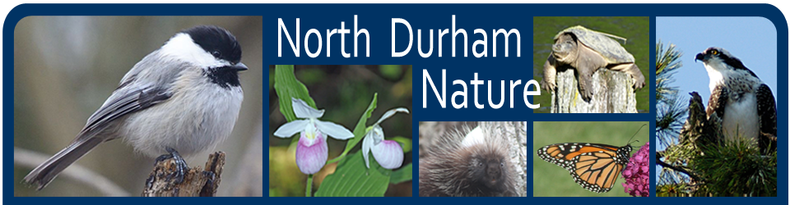
March 15, 2016
Debbie Leroux, Clerk
Township of Uxbridge
51 Toronto Street South
P.O. Box 190
Uxbridge, Ontario
L9P 1T1

dleroux@town.uxbridge.on.ca

Dear Madame Clerk:

We recently read in the Uxbridge newspaper that Council has asked staff to consider amending local bylaws to introduce a “trap, neuter and release” (TNR) program for feral cats in Uxbridge.

The Board of Directors of North Durham Nature wishes to go on record as being strongly opposed to such an initiative. Feral cats are a devastating influence on native wildlife. Recent studies show that, in Canada, cats-at-large (i.e. free-ranging house cats and feral cats) annually kill five per cent of Canadian birds — that’s 269 million birds killed every year in Canada by cats.

Around the world, domestic cats are recognized as a threat to global biodiversity
and are known to have significantly contributed to the extinction of 33 species. The
impacts are so great that the International Union for the Conservation of Nature
(IUCN) now lists domestic cats as one of the world’s worst non-native invasive
species.

TNR programs have been proven historically to be ineffective and in fact often generate outcomes exactly opposite of what is desired. In one study in Hawaii, feral cat populations increased ten-fold after TNR was introduced. There were many reasons for this, but one that stands out is the fact that people became complacent about releasing their pets into the wild as they know someone else will care for them. This is a common and negative outcome of TNR.

Uxbridge touts itself as the Trail’s Capital of Canada and proudly encourages residents and visitors to explore the flora and fauna. The health of the pollinator community and eradication projects for invasive species are being considered both here and in neighbouring communities. Both are positive initiatives and both lead to a healthier natural community. Cats-at-large and feral cats are not part of a natural community and never have been. They are as alien as Phragmites or Emerald Ash Borer and, at least for birds, more devastating. There is no place for them anywhere in a natural environment and, if anything, they should be eradicated not fostered.

We realize this is an emotional issue but is forfeiting the lives of millions of birds and mammals justification enough to permit these uncontrolled hunters from devastating local populations? Is it not enough that climate change, habitat loss, pesticides, and urban sprawl have diminished most of the songbird and grassland populations in North America by 50-70% over the last 50 years? The movie “The Messenger”, which aired in Uxbridge recently, warns of the plight of songbirds across the world and specifically in North America.

There is much information on the web to better explain the devastating impacts cats on avian, amphibian and mammalian populations. Another new intuitive has just been announced called “Keep cats safe and save birds lives” (www.catsandbirds.ca) that explains how keeping cats indoors can not only save them but will ensure that millions of wild animals are not unnecessarily killed each year.

We trust that staff will consider our position and do some careful research into the problems and impacts of feral cats before recommending any amendment to Township bylaws.

Thank-you for considering our comments.

Sincerely,

Derek Connelly
President
North Durham Nature

18 Second Ave, Uxbridge, ON, L9P 1J9
ndnature7@gmail.com
www.northdurhamnature.com

